2021-2022
Hot Styles Dance Company
Class Dress Code
(Suggestions on where to find these things will be listed below)

Creative Movement/Dance Discovery- Pink or Black Leotard, Footless Tights, Bare feet or Pink Ballet Shoes

Pre Ballet/Pre Tap- Black Leotard, Pink Capezio Leather Ballet Slippers AND Black Mary Jane either Tie or Buckle Tap Shoes, Pink Footed or Convertible tights (Capezio or BodyWrappers). For Boys: White T Shirt, Black Dance Pants, Black Ballet Shoes

Ballet - Black Leotard, Pink Capezio Leather Ballet Slippers,
Pink Footed or Convertible tights (Capezio or BodyWrappers)
For Boys: White T Shirt, Black Dance Pants, Black Ballet Shoes
Please wear hair in bun if long enough

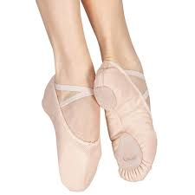
Pointe/PrePointe- Black Leotard, Pink Capezio Leather Ballet Slippers OR Pointe Shoes (Fitted by a store)
Pink Footed or Convertible tights (Capezio or BodyWrappers)
Please wear hair in bun if long enough

Contemporary/ Lyrical - Black Leotard, Pirouettes (Capezio or Block Leather) Tan Stirrup Tights (Capezio or BodyWrappers)

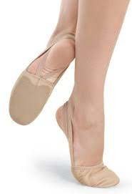
Modern- Black Leotard, Pirouettes (Capezio or Block Leather) Tan Stirrup Tights (Capezio or BodyWrappers)

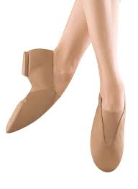
Jazz - Black Leotard, Fitted Shorts or Capris with Tan or Pink Footed or Convertible Tights (Capezio or Bodywrappers). Tan Slip On Jazz Shoes (Either Block “Super Jazz”Shoe , or Theatrical “ Ultimate Competition”)

Tap - Black Leotard, Fitted Shorts or Capris with Tan or Pink Footed or Convertible Tights (Capezio or Bodywrappers). Black Tap Shoes.

Hip Hop-Clothing should consist of active wear that is easy to move in. Students should have a sneaker that they no longer wear outside and will not mark floors. We recommend purchasing the Nike Tanjun Black and White sneaker. This will also be the recital shoe and color so it is highly suggested to purchase. They are the black shoe with white Nike swipe. They are available on many websites and at the Shoe Department in the mall.

Acro-Clothing should consist of fitted active wear that is easy to move in. No baggie clothing. Example would be a leo with gym/dance shorts. Bare Feet.

Adult Classes- Clothing must be active wear and form fitting, you may wear leotards and tights but it is not required. Please wear the appropriate shoe for styles of dance.
Ballet- Ballet Shoes
Modern- Ballet Shoes or Pirouettes
Jazz- Jazz Shoes
Hip Hop-Sneakers (that are no longer worn outside)

- If you are enrolled in a combo class please refer to both styles of dance dress codes

- All Listed requirements for Shoes (besides hip hop shoes), Tights, or Leotards can be found either on:
  - Amazon.com
  - DiscountDance.com- Use Studio/Teacher Code #110749 and receive 8% off first order and additional perks.
  - Physique Boutique in State College
  - The Dance Shop in Altoona (This place is better for fitting pointe shoes)

Any questions please email hotstylesdance@yahoo.com

